Impact of Rumen-Protected Choline Supplementation on Growth and Health in Ruminants
Min Yan¹, Weiqi Wang¹, Songlin Liu¹, Aiwei Guo¹, Yajin Yang¹, Xu Luo¹, Jinhai Wang^{2*}, Lily Liu^{1,3*}, Qin Zhang⁴
1. College of Biological and Food Engineering, Southwest Forestry University, Kunming 650224, PR China;
2. College of Animal Science and Technology, Northwest A & F University, Yangling 712100, PR China
3. The Roslin Institute, University of Edinburgh, Edinburgh, EH25 9RG, UK
4. College of Animal Science and Technology, Shandong Agricultural University, Tai’an 271018, PR China

*Correspondence: jzw0173@auburn.edu; liulily0518@163.com
College of Animal Science and Technology, Northwest A & F University, Yangling 712100, PR China
College of Biological and Food Engineering, Southwest Forestry University, Kunming, 650224, PR China; The Roslin Institute, University of Edinburgh, Edinburgh EH25 9RG, UK
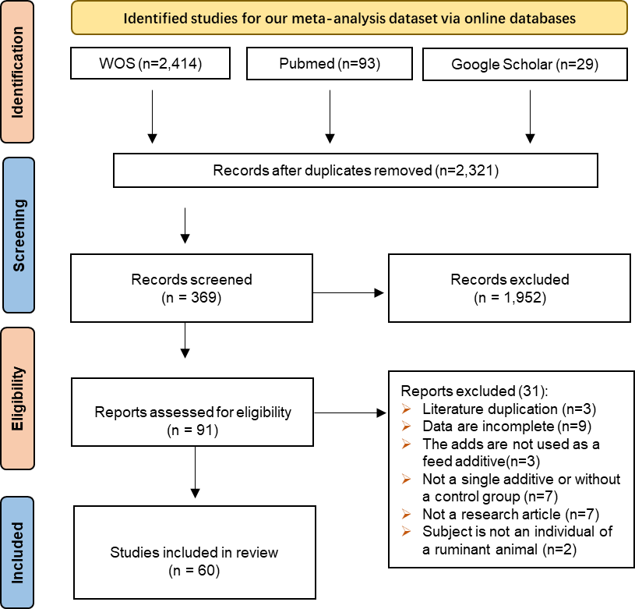
Fig S1. Prisma Flowchart for Study Inclusion. An original search returned 2,536 studies. After a critical evaluation of abstracts and full texts, a total of 60 articles with 2,178 data entries were selected for database development.

Table S1. Overall effect size calculation outcomes and the results from moderator analysis for growth, blood metabolites, production, liver composition, immunity and gene expression. (SMD, standardized mean difference; k, the number of effect sizes for each level of moderators; CI, confidence interval; PI, predicted interval)

Response variables | Subgroup | K | SMD  (Hedges'g) | I² % | 95% CI |  | P-value | 95% PI
 |  |  |  |  | lower | upper | P-value | lower | upper
Growth
Overall |  | 333 | 0.23 | 74.80 | 0.07 | 0.39 | 0.01 | -1.11 | 1.58
Parameter | WH | 23 | 0.72 |  | 0.31 | 1.12 |  | -0.67 | 2.10
Parameter | Hips | 8 | 0.70 |  | 0.13 | 1.28 |  | -0.74 | 2.14
Parameter | HG | 15 | 0.38 |  | -0.12 | 0.88 |  | -1.03 | 1.80
Parameter | FCE | 33 | 0.19 |  | -0.14 | 0.53 |  | -1.17 | 1.56
Parameter | DMI | 100 | 0.22 |  | 0.02 | 0.43 |  | -1.12 | 1.56
Parameter | BW | 8 | 0.39 |  | -0.17 | 0.95 |  | -1.05 | 1.83
Parameter | BCS | 43 | 0.05 |  | -0.24 | 0.34 |  | -1.30 | 1.41
Parameter | ADG | 95 | 0.26 |  | 0.02 | 0.49 |  | -1.09 | 1.60
Parameter | ADFI | 8 | 0.48 |  | -0.17 | 1.14 |  | -0.99 | 1.96
Species | Sheep | 93 | 0.45 |  | 0.15 | 0.75 |  | -0.88 | 1.79
Species | Goat | 25 | 0.17 |  | -0.33 | 0.67 |  | -1.22 | 1.57
Species | dairy cow | 206 | 0.11 |  | -0.08 | 0.29 |  | -1.21 | 1.42
Species | beef | 9 | 0.56 |  | 0.24 | 0.87 |  | -0.78 | 1.89
Blood metabolites
Overall |  | 753 | 0.03 | 79.02 | -0.11 | 0.17 | 0.67 | -1.46 | 1.53
parameter | ALB | 26 | 0.04 |  | -0.31 | 0.39 |  | -1.32 | 1.41
parameter | ALP | 18 | -0.09 |  | -0.51 | 0.33 |  | -1.47 | 1.30
parameter | ALT | 29 | 0.18 |  | -0.16 | 0.53 |  | -1.18 | 1.55
parameter | AST | 43 | -0.08 |  | -0.36 | 0.20 |  | -1.43 | 1.27
parameter | BET | 15 | 0.41 |  | -0.03 | 0.85 |  | -0.98 | 1.80
parameter | BHB | 80 | -0.05 |  | -0.26 | 0.15 |  | -1.39 | 1.28
parameter | BUN | 53 | -0.33 |  | -0.57 | -0.09 |  | -1.67 | 1.01
parameter | CRE | 29 | -0.25 |  | -0.60 | 0.11 |  | -1.61 | 1.12
parameter | FIB | 14 | 0.01 |  | -0.56 | 0.58 |  | -1.43 | 1.45
parameter | GGT | 25 | -0.16 |  | -0.52 | 0.20 |  | -1.53 | 1.21
parameter | Glu | 98 | 0.10 |  | -0.09 | 0.30 |  | -1.26 | 1.44
parameter | GSH | 7 | -0.16 |  | -0.82 | 0.50 |  | -1.64 | 1.31
parameter | IGF-1 | 9 | 0.80 |  | 0.23 | 1.37 |  | -0.64 | 2.23
parameter | CHO | 78 | 0.04 |  | -0.15 | 0.23 |  | -1.38 | 1.46
parameter | Insulin | 34 | 0.05 |  | -0.24 | 0.34 |  | -1.39 | 1.49
parameter | NEFA | 74 | -0.11 |  | -0.30 | 0.09 |  | -1.53 | 1.32
parameter | OSI | 8 | -0.14 |  | -0.45 | 0.46 |  | -1.68 | 1.39
parameter | P4 | 41 | 1.28 |  | 1.01 | 1.56 |  | -0.15 | 2.72
parameter | RQUICKI | 8 | 1.82 |  | 1.20 | 2.44 |  | 0.28 | 3.36
parameter | SOD | 4 | 0.65 |  | -0.20 | 1.51 |  | -0.99 | 2.30
parameter | TAS | 12 | 0.31 |  | -0.19 | 0.81 |  | -1.18 | 1.80
parameter | TBIL | 20 | 0.02 |  | -0.37 | 0.41 |  | -1.44 | 1.48
parameter | TOS | 8 | 0.36 |  | -0.26 | 0.97 |  | -1.18 | 1.89
parameter | TP | 20 | -0.06 |  | -0.45 | 0.33 |  | -1.52 | 1.40
Species | Beef | 16 | -0.43 |  | -0.93 | 0.08 |  | -2.02 | 1.17
Species | Buffalo | 52 | -0.35 |  | -0.90 | 0.19 |  | -1.97 | 1.26
Species | Dairy cow | 415 | 0.09 |  | -0.10 | 0.28 |  | -1.44 | 1.61
Species | Goat | 48 | -0.04 |  | -0.50 | 0.42 |  | -1.66 | 1.54
Species | Sheep | 222 | 0.10 |  | -0.26 | 0.47 |  | -1.45 | 1.67
Production
Overall |  | 425 | 0.28 | 79.55 | 0.03 | 0.53 | 0.03 | -1.28 | 1.84
Parameter | Milk density | 8 | -0.53 |  | -1.13 | 0.06 |  | -2.18 | 1.11
Parameter | MFP | 47 | 0.17 |  | -0.15 | 0.48 |  | -1.40 | 1.73
Parameter | MFY | 38 | 0.41 |  | 0.08 | 0.73 |  | -1.16 | 1.97
Parameter | MLP | 31 | 0.27 |  | -0.08 | 0.62 |  | -1.30 | 1.84
Parameter | MLY | 17 | 0.20 |  | -0.20 | 0.59 |  | -1.39 | 1.78
Parameter | MPP | 49 | 0.08 |  | -0.23 | 0.39 |  | -1.49 | 1.64
Parameter | MPY | 37 | 0.24 |  | -0.09 | 0.56 |  | -1.33 | 1.80
Parameter | MSP | 14 | -0.02 |  | -0.50 | 0.45 |  | -1.63 | 1.58
Parameter | MSY | 4 | 0.32 |  | -0.42 | 1.06 |  | -1.38 | 2.02
Parameter | MUN | 24 | 0.25 |  | -0.15 | 0.64 |  | -1.33 | 1.83
Parameter | MY | 142 | 0.43 |  | 0.17 | 0.70 |  | -1.12 | 1.99
Parameter | SNFP | 14 | 0.07 |  | -0.41 | 0.55 |  | -1.53 | 1.68
Species | Buffalo | 79 | 1.00 |  | 0.18 | 1.83 |  | -0.73 | 2.74
Species | Dairy cow | 289 | 0.28 |  | -0.04 | 0.59 |  | -1.28 | 1.83
Species | Goat | 19 | 0.13 |  | -0.50 | 0.76 |  | -1.52 | 1.78
Species | Sheep | 38 | -0.03 |  | -0.74 | 0.67 |  | -1.71 | 1.65
Liver composition
Overall |  | 211 | 0.06 | 65.18 | -0.16 | 0.27 | 0.61 | -0.16 | 0.27
Parameter | FAD | 39 | -0.01 |  | -0.27 | 0.25 |  | -1.08 | 1.05
Parameter | HDL | 25 | 0.07 |  | -0.29 | 0.42 |  | -1.03 | 1.16
Parameter | LDL | 25 | 0.29 |  | -0.06 | 0.64 |  | -0.80 | 1.38
Parameter | PC | 35 | 0.33 |  | 0.01 | 0.66 |  | -0.75 | 1.41
Parameter | TAG | 52 | -0.12 |  | -0.37 | 0.13 |  | -1.18 | 0.94
Parameter | TAGp | 24 | -0.01 |  | -0.30 | 0.30 |  | -1.08 | 1.08
Parameter | VLDL | 11 | 0.42 |  | -0.01 | 0.86 |  | -0.70 | 1.54
Species | Beef | 8 | 0.17 |  | -0.41 | 0.76 |  | -1.06 | 1.41
Species | Buffalo | 16 | 0.45 |  | -0.58 | 1.48 |  | -1.05 | 1.94
Species | Dairy cow | 130 | 0.10 |  | -0.15 | 0.36 |  | -1.01 | 1.22
Species | Sheep | 57 | -0.19 |  | -0.68 | 0.31 |  | -1.38 | 1.01
Immunity
Overall |  | 111 | -0.29 | 76.83 | -0.50 | -0.08 | 0.01 | -1.68 | 1.10
Parameter | Hap | 42 | -0.32 |  | -0.64 | -0.01 |  | -1.75 | 1.11
Parameter | IgG | 4 | -0.24 |  | -1.04 | 0.57 |  | -1.85 | 1.38
Parameter | LBP | 10 | -0.59 |  | -1.13 | -0.05 |  | -2.09 | 0.91
Parameter | Leu | 22 | 0.16 |  | -0.49 | 0.81 |  | -1.38 | 1.70
Parameter | SAA | 12 | -0.57 |  | -1.28 | 0.14 |  | -2.14 | 1.00
Parameter | SCS | 12 | 0.20 |  | -0.35 | 0.74 |  | -1.30 | 1.70
Parameter | TNFα | 9 | -0.62 |  | -1.16 | -0.07 |  | -2.12 | 0.88
Species | Buffalo | 30 | -0.79 |  | -1.30 | -0.28 |  | -2.36 | 0.78
Species | Dairy cow | 81 | -0.20 |  | -0.52 | 0.11 |  | -1.72 | 1.31
Gene expression
Overall |  | 345 | -0.04 | 22.26 | -0.24 | 0.15 |  | -0.56 | 0.47
Parameter | AA M | 13 | -0.08 |  | -0.39 | 0.23 |  | -0.57 | 0.41
Parameter | Apoptosis | 18 | -0.03 |  | -0.31 | 0.25 |  | -0.50 | 0.44
Parameter | Carb M | 5 | 0.03 |  | -0.37 | 0.43 |  | -0.52 | 0.58
Parameter | Cholin M | 6 | 0.10 |  | -0.31 | 0.51 |  | -0.45 | 0.66
Parameter | Energy M | 48 | -0.20 |  | -0.43 | 0.03 |  | -0.64 | 0.24
Parameter | Immunity | 137 | -0.14 |  | -0.34 | 0.05 |  | -0.57 | 0.28
Parameter | Lipid M | 54 | 0.06 |  | -0.14 | 0.26 |  | -0.37 | 0249
Parameter | Meth | 38 | 0.09 |  | -0.13 | 0.32 |  | -0.34 | 0.53
Parameter | OSp | 26 | -0.20 |  | -0.44 | 0.04 |  | -0.65 | 0.24
Species | Dairy cow | 339 | -0.03 |  | -0.26 | 0.19 |  | -0.60 | 0.53
Species | Goat | 6 | -0.10 |  | -0.70 | 0.49 |  | -0.89 | 0.69

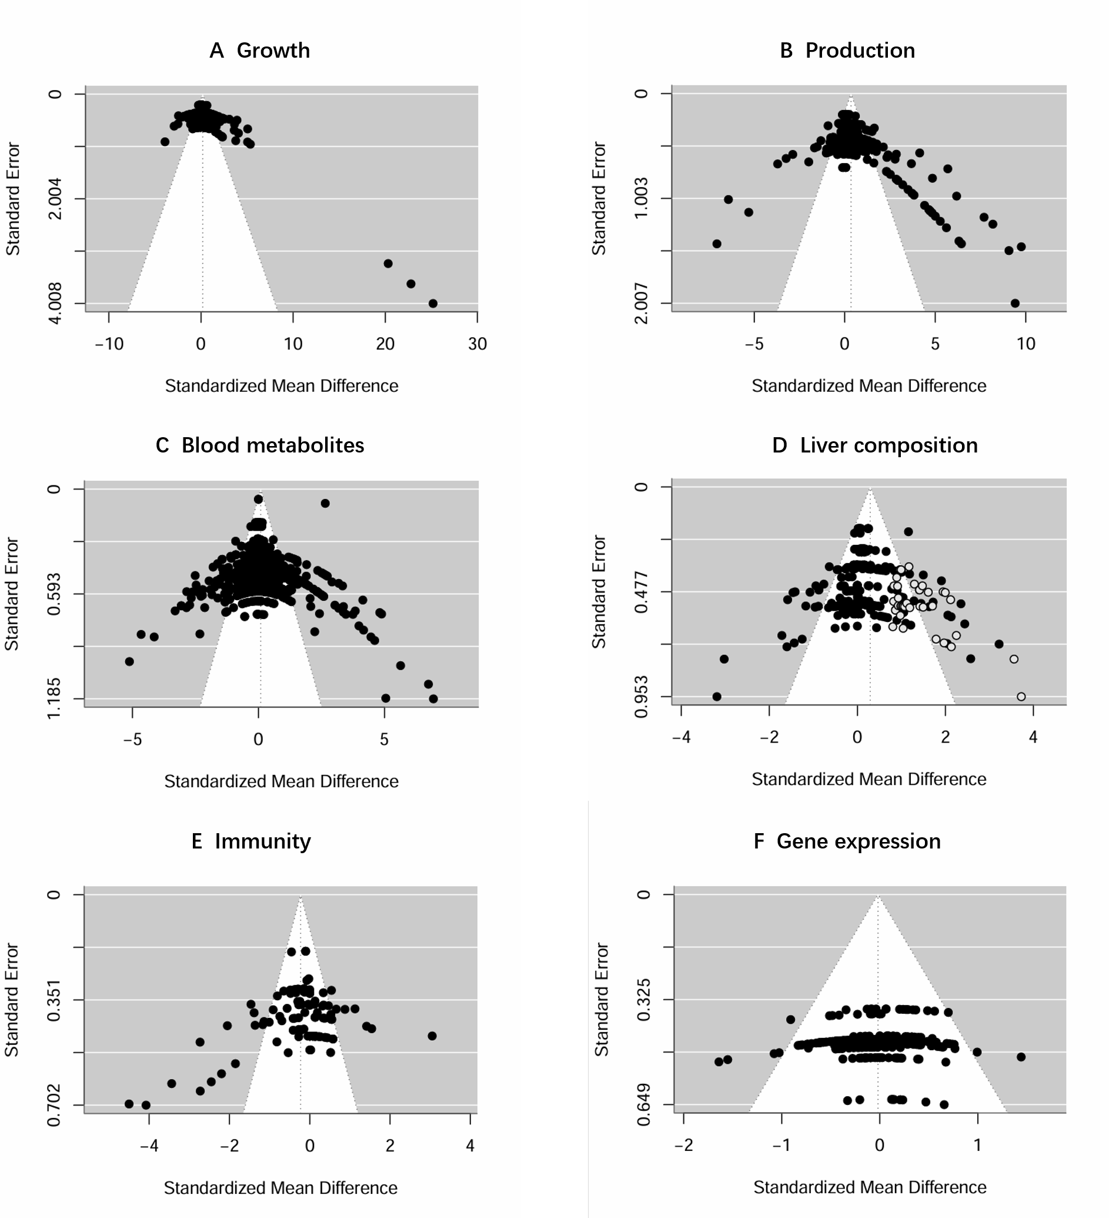
Fig S2. Funnel plots and Egger's test showed that there was potential publication bias for (A) growth, (B) performance, (C) liver composition, (D) blood metabolites, (E) immunity, and (F) gene expression. The horizontal axis is the effect size, and the vertical axis is the Standard Error. The dashed line shows the overall effect size, and the slanted box shows the 95% confidence interval.
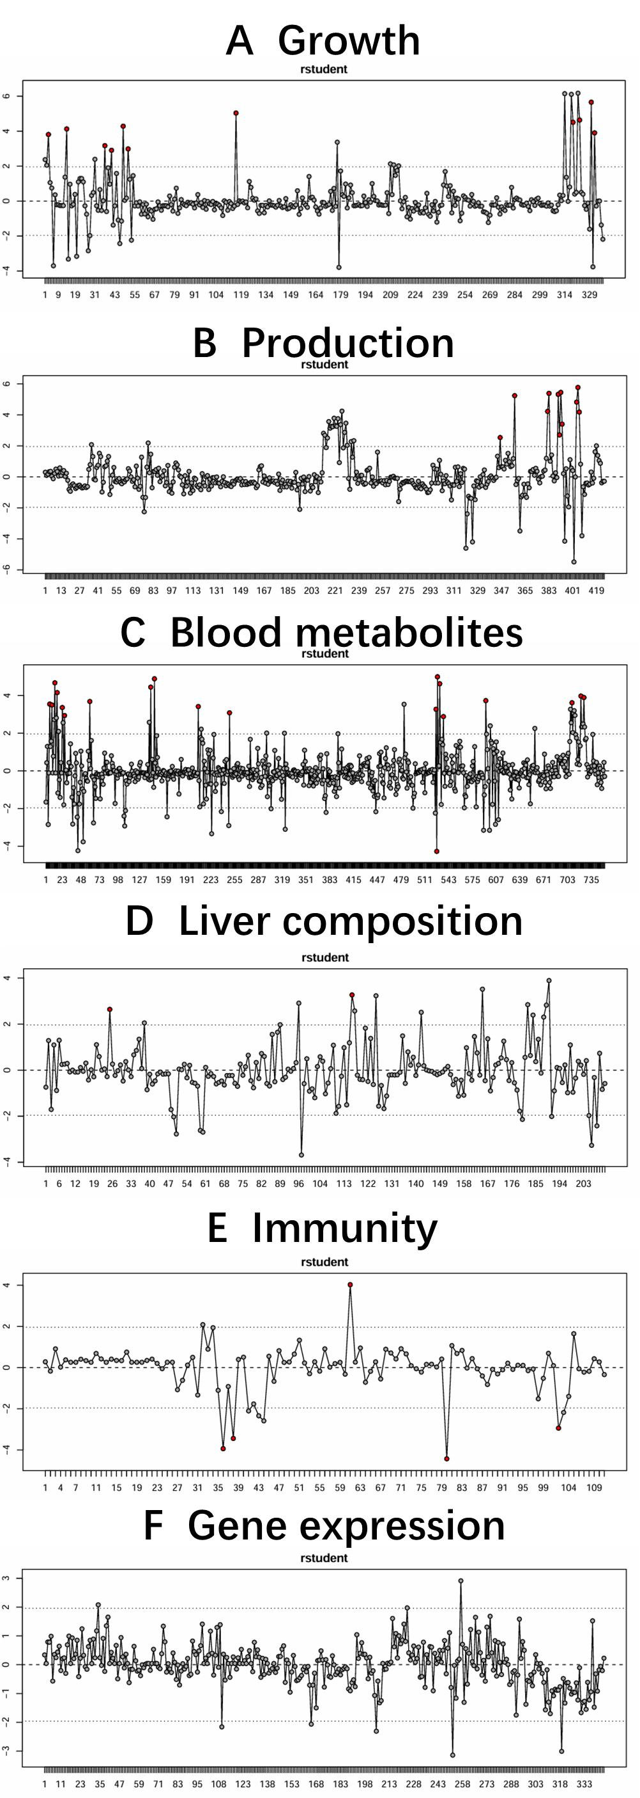
Fig S3. Sensitivity analysis for impact-outlier diagnostic scatterplots for (A) growth, (B) performance, (C) liver composition, (D) blood metabolites, (E) immunity, and (F) gene expression. Where the vertical axis represents the values of the rstudent for sensitivity analyses, and each dot corresponds to the value of one piece of data. Black dots indicate that the corresponding data is not anomalous and red dots indicate that the corresponding data is an outlier. 11, 11, 19, 2, and 5 outliers in the categories of growth, production, blood metabolism, liver composition, and immunity.
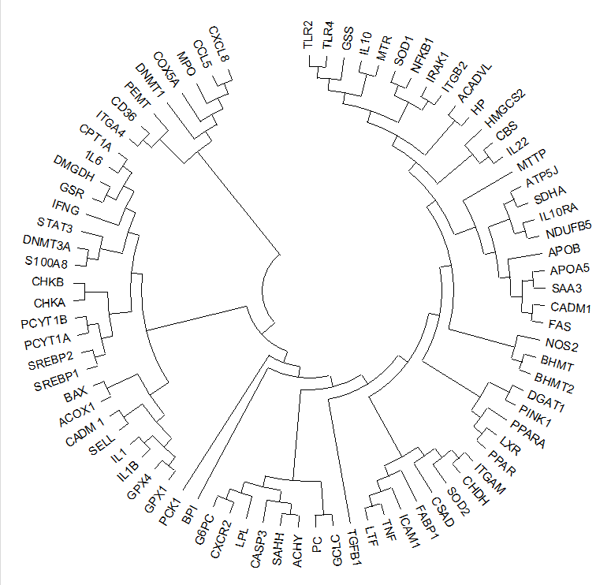
Fig S4. Phylogenetic tree of protein evolutionary relationships carried out for the genes extracted from the constructed articles. CXCL8, C-X-C motif chemokine ligand 8; CCL5, C-C motif chemokine ligand 5; MPO, myeloperoxidase; COX5A, cytochrome c oxidase subunit 5A; DNMT1, DNA methyltransferase 1; PEMT, phosphatidylethanolamine N-methyltransferase; CD36, CD36 molecule; ITGA4, integrin subunit alpha 4; CPT1A, carnitine palmitoyltransferase 1A; IL6, interleukin 6; DMGDH, dimethylglycine dehydrogenase; GSR, glutathione-disulfide reductase; IFNG, interferon gamma; STAT3, signal transducer and activator of transcription 3; DNMT3A, DNA methyltransferase 3 alpha; S100A8, S100 calcium binding protein A8; CHKB, choline kinase beta; CHKA, choline kinase alpha; PCYT1B, phosphate cytidylyltransferase 1B; PCYT1A, phosphate cytidylyltransferase 1A; SREBF2, sterol regulatory element binding transcription factor 2; SREBF1, sterol regulatory element binding transcription factor 1; BAX, BCL2 associated X; ACOX1, acyl-CoA oxidase 1; CADM1, cell adhesion molecule 1; SELL, selectin L; IL1B, interleukin 1 beta; GPX4, glutathione peroxidase 4; GPX1, glutathione peroxidase 1; PCK1, phosphoenolpyruvate carboxykinase 1; BPI, bactericidal permeability increasing protein; G6PC, glucose-6-phosphatase catalytic subunit; CXCR2, C-X-C motif chemokine receptor 2; LPL, lipoprotein lipase; CASP3, caspase 3; SAHH, S-Adenosylhomocysteine Hydrolase; PC, pyruvate carboxylase; GCLC, glutamate-cysteine ligase catalytic subunit; TGFB1, transforming growth factor beta 1; LTF, lactotransferrin; TNF, tumor necrosis factor; ICAM1, intercellular adhesion molecule 1; FABP1, fatty acid binding protein 1; CSAD, cysteine sulfinic acid decarboxylase; SOD2, superoxide dismutase 2; CHDH, choline dehydrogenase; ITGAM, integrin subunit alpha M; PPAR, peroxisome proliferator activated receptor gamma; PPARA, peroxisome proliferator activated receptor alpha; LXR, Liver X Receptor; PINK1, PTEN induced kinase 1; DGAT1, diacylglycerol O-acyltransferase 1; BHMT2, betaine-homocysteine S-methyltransferase 2; BHMT, betaine-homocysteine S-methyltransferase; NOS2, nitric oxide synthase 2; FAS, Fas cell surface death receptor; CADM1, cell adhesion molecule 1; SAA3, serum amyloid A 3; APOA5, apolipoprotein A5; APOB, apolipoprotein B; NDUFB5, NADH: ubiquinone oxidoreductase subunit B5; IL10RA, interleukin 10 receptor alpha; SDHA, succinate dehydrogenase complex flavoprotein subunit A; ATP5J, ATP synthase peripheral stalk subunit F6; MTTP, microsomal triglyceride transfer protein; IL22, interleukin 22; CBS, cystathionine beta-synthase; HMGCS2, 3-hydroxy-3-methylglutaryl-CoA synthase 2; HP, haptoglobin; ACADVL, acyl-CoA dehydrogenase very long chain; ITGB2, integrin beta 2; IRAK1, interleukin-1 receptor-associated kinase 1; NFKB1, nuclear factor kappa B subunit 1; SOD1, superoxide dismutase 1; MTR, 5-methyltetrahydrofolate-homocysteine methyltransferase; IL10, interleukin 10; GSS, glutathione synthetase; TLR4, toll like receptor 4; TLR2, toll like receptor 2.

